**Customer Support Data Analysis Report**

**By: Philip Leteipa Kiseento**

**Data Analyst Intern  
Date: 27/04/2025**

**Executive Summary**

This report presents an analysis of customer support tickets to identify key trends in resolution times, ticket priorities, and frequent customer issues. The analysis highlights critical bottlenecks in ticket resolution times and provides actionable insights that could improve the customer support process. The goal of this project was to explore ticket data, identify common issues, and recommend data-driven solutions for improving support ticket management.

**Introduction**

**Problem Statement**

Customer support teams face challenges in managing a large volume of tickets efficiently. With the goal of improving both customer satisfaction and team productivity, the company needed a detailed analysis of support ticket data to identify patterns in ticket resolution times, frequent issues, and areas that could benefit from optimization.

**Objective**

This analysis aimed to:

* Identify the most frequent issues reported by customers.
* Analyze resolution times by ticket priority.
* Provide recommendations to improve response efficiency and automate responses for common issues.

**Data Exploration & Preprocessing**

**Data Overview**

The dataset used in this analysis contains customer support ticket details, including:

* **Ticket ID**: Unique identifier for each support ticket.
* **Customer Name and Email**: Customer information.
* **Ticket Type**: Type of support issue (e.g., Technical Issue, Billing Inquiry).
* **Ticket Description**: Detailed description of the issue.
* **Ticket Priority**: Urgency of the ticket (Critical, High, Medium, Low).
* **Time to Resolution**: Time taken to resolve the ticket.
* **Customer Satisfaction Rating**: Rating given by customers after ticket resolution.

**Data Cleaning**

Several steps were taken to clean and prepare the data:

* Removed rows with missing values for the essential columns: "First Response Time" and "Time to Resolution."
* Processed the "Ticket Description" column to remove stopwords and punctuation, making it suitable for text analysis.
* Converted "First Response Time" and "Time to Resolution" columns into datetime objects to calculate resolution times in hours.

**Text Preprocessing**

The text data in the "Ticket Description" column was preprocessed by:

* Converting text to lowercase.
* Removing stopwords (e.g., "the," "is," "and") using the NLTK library.
* Tokenizing the text and filtering out non-relevant words for further analysis.

**Exploratory Data Analysis (EDA)**

**Ticket Description Analysis**

A word frequency analysis was conducted on ticket descriptions to identify the most common words reported by customers. The top 15 most frequent words were identified, providing insights into common issues customers face.

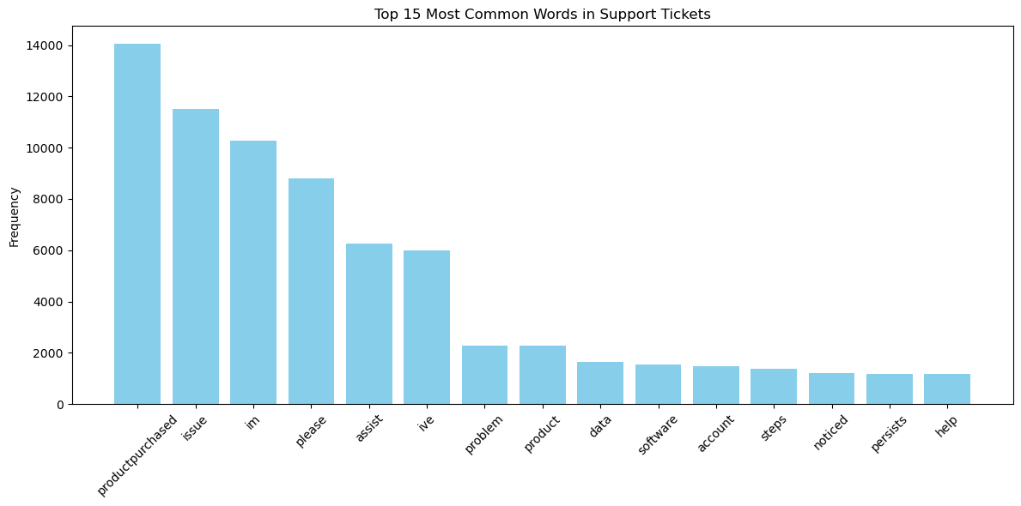

**Ticket Priority Analysis**

An analysis of ticket priorities revealed the following average resolution times by priority:

* **Critical**: 7.15 hours
* **Medium**: 7.17 hours
* **Low**: 7.95 hours
* **High**: 8.07 hours

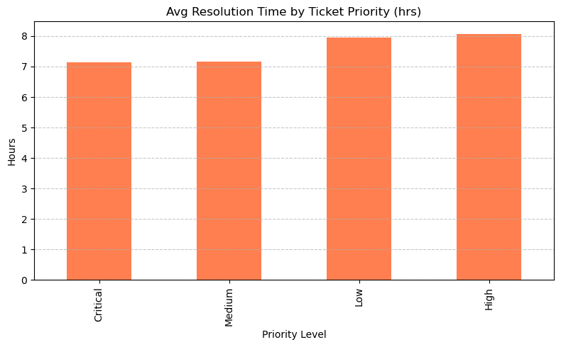

This suggests that critical tickets are being resolved at similar rates to medium-priority tickets, while low and high-priority tickets have longer resolution times.

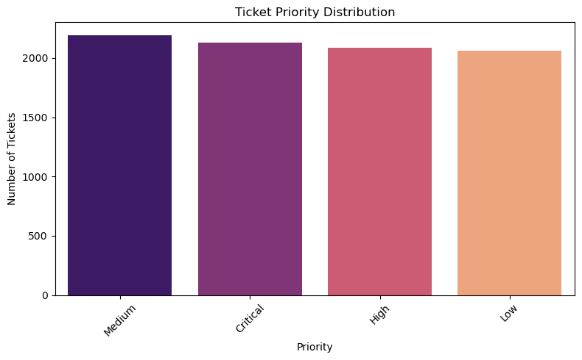

**Ticket Type Distribution**

The distribution of ticket types indicated that "Technical Issues" were the most frequent type of request, followed by "Billing Inquiries." This pattern helps identify areas where automation could be beneficial.

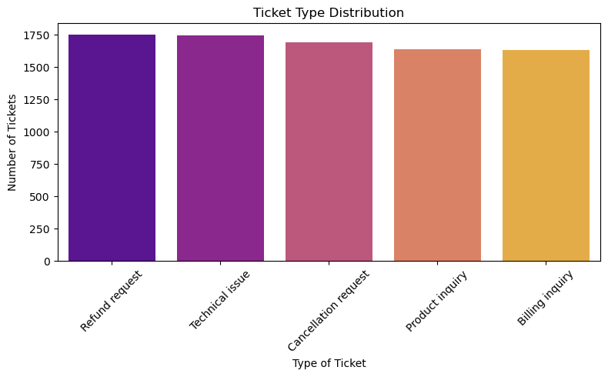

**Time to Resolution Analysis**

For tickets with valid "First Response Time" and "Time to Resolution" values, the average resolution time for each ticket priority was calculated. This time-to-resolution analysis helps pinpoint inefficiencies in ticket management.

**Analysis & Findings**

**Key Insights**

* **Frequent Issues**: The most common ticket descriptions were related to technical problems, such as product setup and compatibility issues.
* **Ticket Priorities**: While "Critical" tickets were expected to be resolved quickly, they had similar resolution times to "Medium" priority tickets. This suggests that more resources should be allocated to "Critical" tickets to ensure faster resolution.
* **Resolution Time Variations**: Low and high-priority tickets had higher average resolution times, indicating potential inefficiencies in handling these tickets.

**Patterns**

* Technical issues were consistently the most common, accounting for a significant portion of the ticket types.
* Resolution times showed minor discrepancies across different priorities, highlighting areas for improvement.

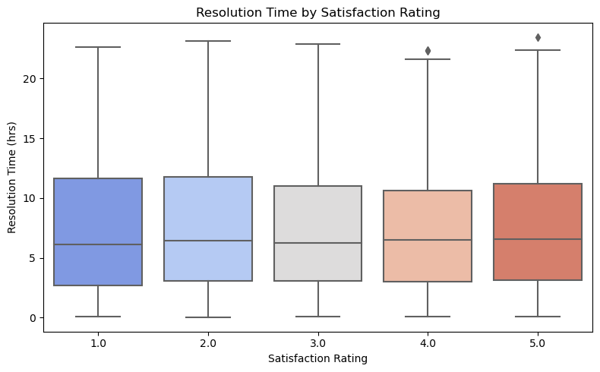

**Recommendations**

Based on the findings from the data analysis, the following recommendations are made:

* **Automate Responses**: Develop automated responses or chatbots for common technical issues to improve response times and reduce workload on support teams.
* **Resource Allocation**: Prioritize resources and team members to handle critical tickets more efficiently to ensure faster resolution.
* **Improve Processes for Low/High-Priority Tickets**: Investigate processes surrounding low and high-priority tickets to identify bottlenecks and reduce resolution times.
* **Monitor Trends**: Continuously monitor ticket resolution times and customer satisfaction to identify trends and potential regressions.

**Conclusion**

This analysis has provided valuable insights into the handling of customer support tickets. By focusing on the most frequent issues, prioritizing critical tickets, and optimizing the handling of low and high-priority tickets, customer support teams can significantly improve their efficiency and overall customer satisfaction. The recommendations provided offer a roadmap for future improvements that can drive better service delivery and customer experiences.

**References**

* Python Libraries: Pandas, Matplotlib, Seaborn, NLTK
* Dataset: [Customer Support Ticket Dataset]